MongoDB Restaurant Analysis
Name:Suriya A
Roll No:23AD144
Dept:AI&DS

- Create database – restaurant, create collection – rescollection. Insert the documents into collections.
db.getCollectionInfos()

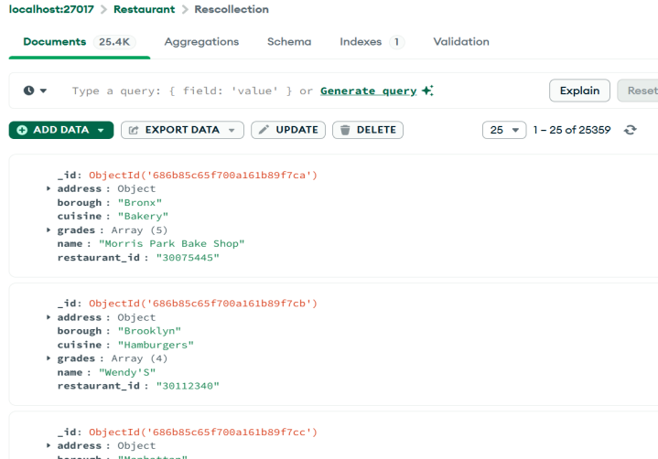
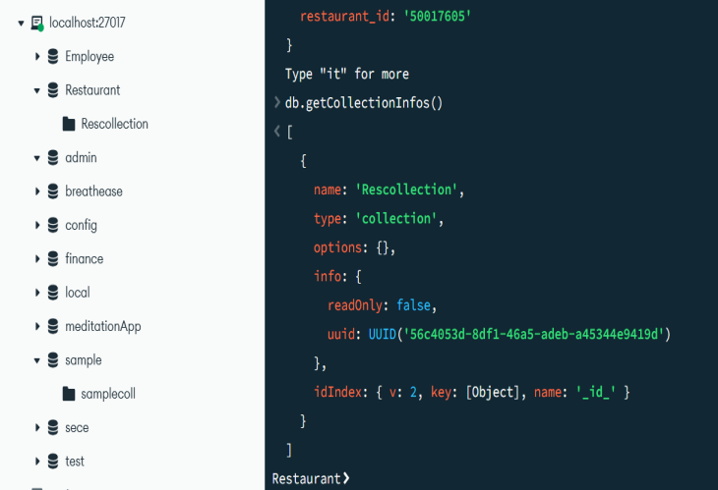

- Display all the documents in the collection restaurants.
db.Rescollection.find()
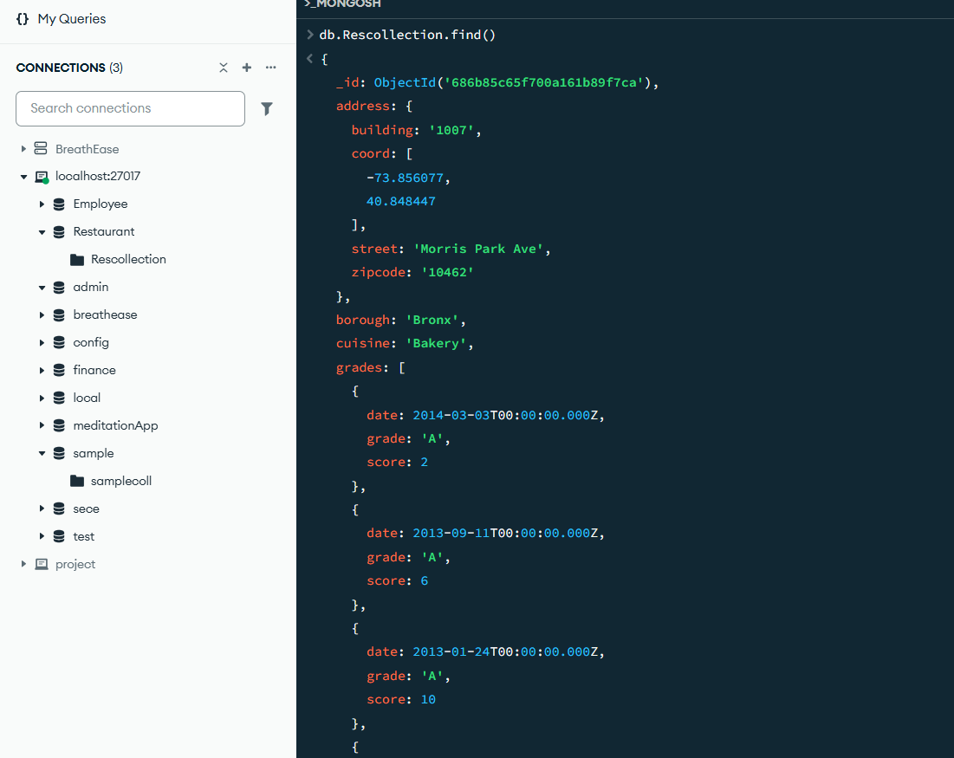

- Display the fields restaurant_id, name, borough, and zip code, but exclude the field _id for all the documents in the collection restaurant.
db.Rescollection.find({},{_id:0,restaurant_id:1,name:1,borough:1,"address.zipcode":1})
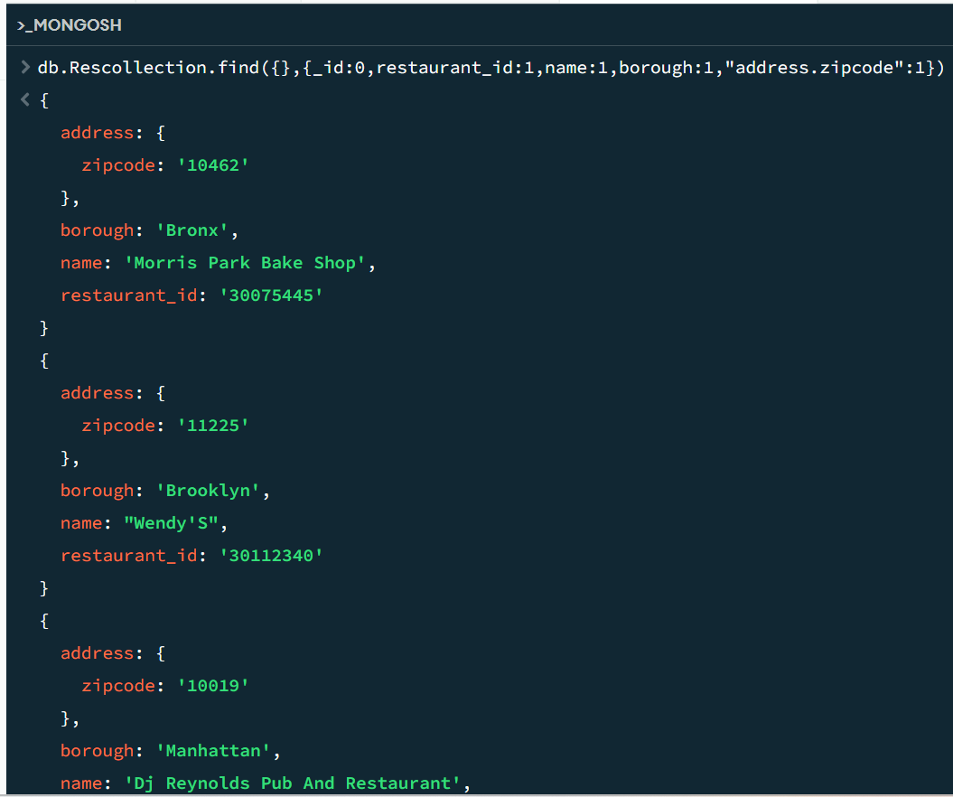

- Find the restaurants who achieved a score more than 90.
db.Rescollection.find({"grades.score" : {$gt:90}})
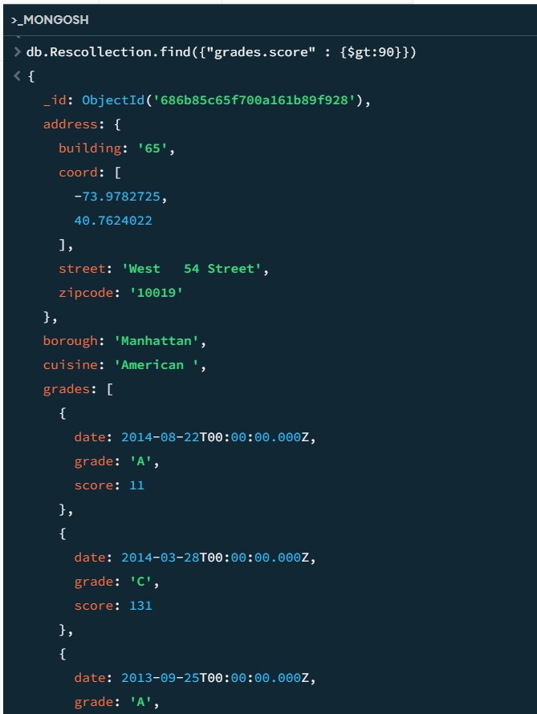

- Show the restaurants that achieved a score, more than 80 but less than 100.
db.Rescollection.find({"grades.score" : {$gt:80, $lt:100}})
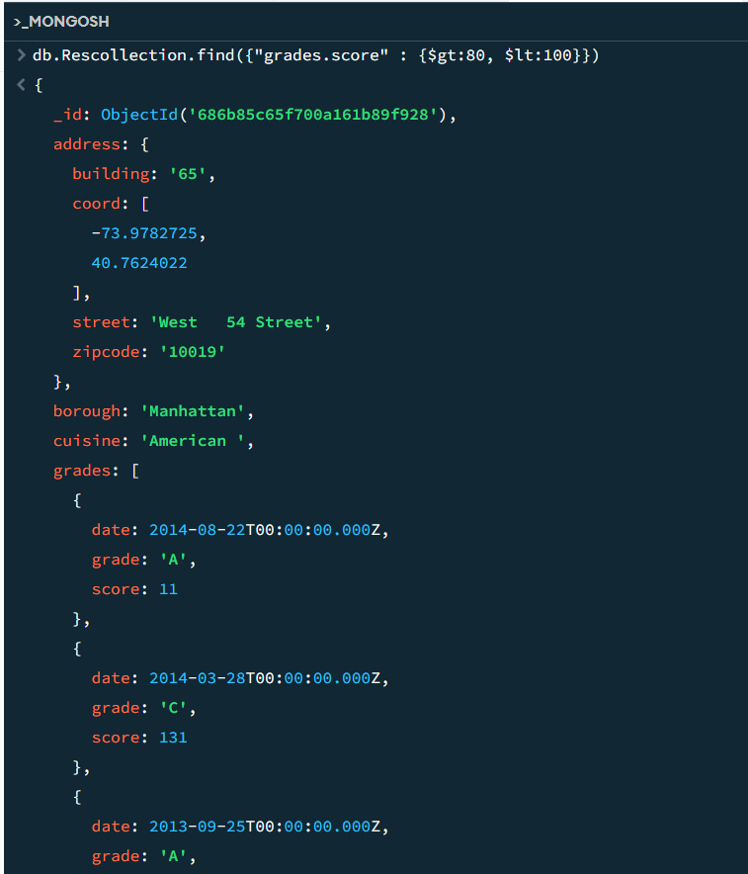

- Write Query to show the restaurants that do not prepare any cuisine of american & their grade score > 70.
db.Rescollection.find($and{cuisine: { $not: /^ *American *$/i }} , "grades.score" : {$gt:70}})
(Or)
db.Rescollection.find({$and:[{"grades.score":{$gt:70}},{cuisine:{$ne:"American "}}]}).limit(3)
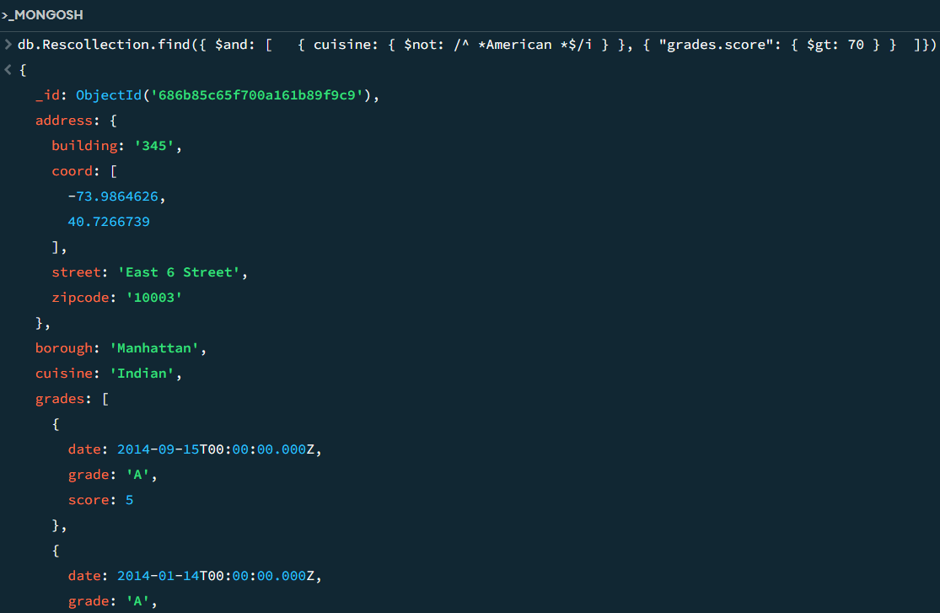

- Write a MongoDB query to arrange the name of the cuisine in an ascending order and for that same borough arranged in descending order.

db.Rescollection.find().sort({cuisine:1,borough:-1})

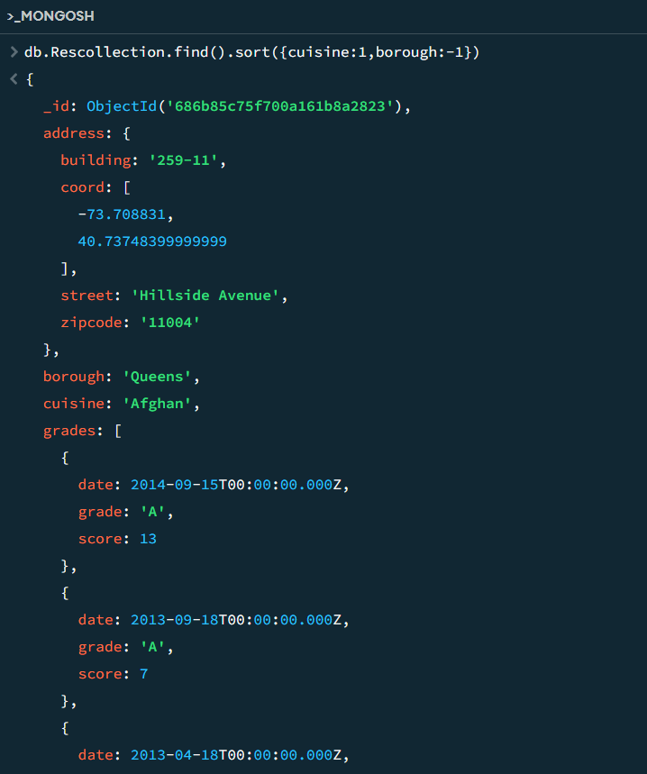

\

- Write a MongoDB query to arrange the name of the cuisine in descending order and cuisines not equal to "Italian"
db.Rescollection.find({cuisine:{$ne:"Italian "}}).sort({cuisine:-1}).limit(3)
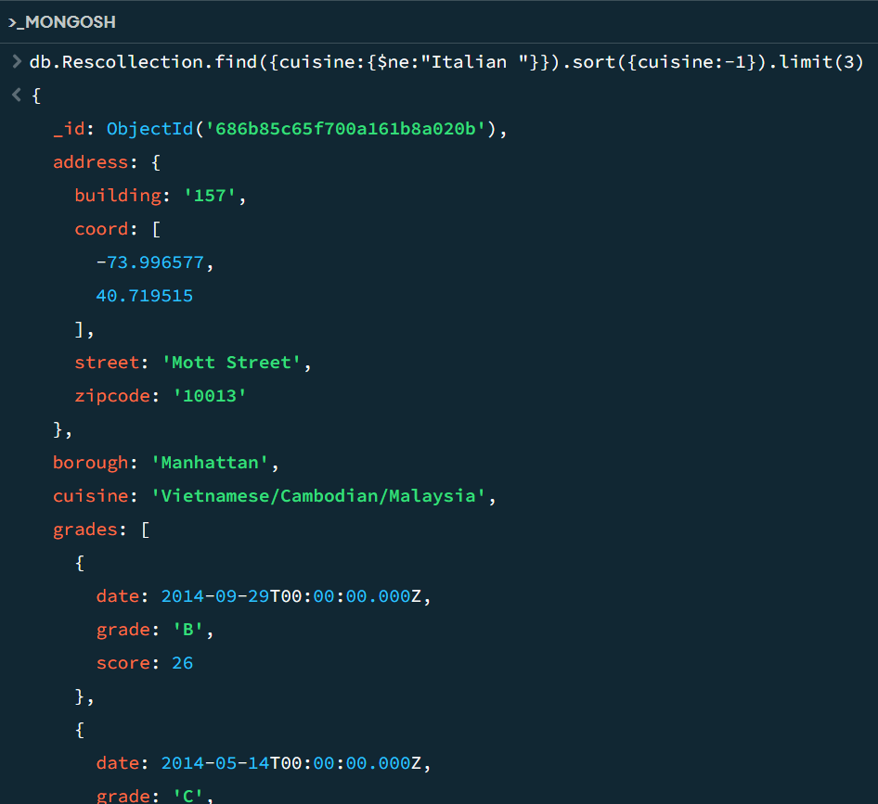

- Show the restaurant Id, name, borough and cuisines for those restaurants which prepared dish except 'American ' and 'Chinese' or restaurant's name begins with letter 'Bil'.

db.Rescollection.find( { $or: [ { cuisine: { $nin: ["American ", "Chinese"] } }, { name: { $ne: "Bil" } } ] }, { _id: 0, restaurant_id: 1, name: 1, borough: 1, cuisine: 1 })
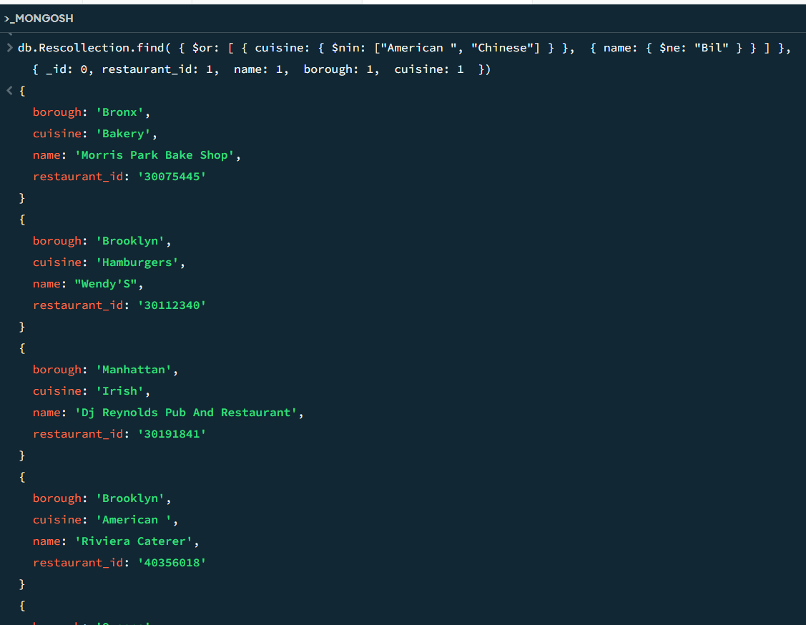

- Show the restaurant Id, name, borough and cuisines and max score for restaurant serving “Indian” as cuisines.

db.Rescollection.aggregate([{ $match: { cuisine: "Indian" } },{$project: {_id: 0,restaurant_id: 1, name: 1,borough: 1, cuisine: 1, max_score: { $max: "$grades.score" }} }])
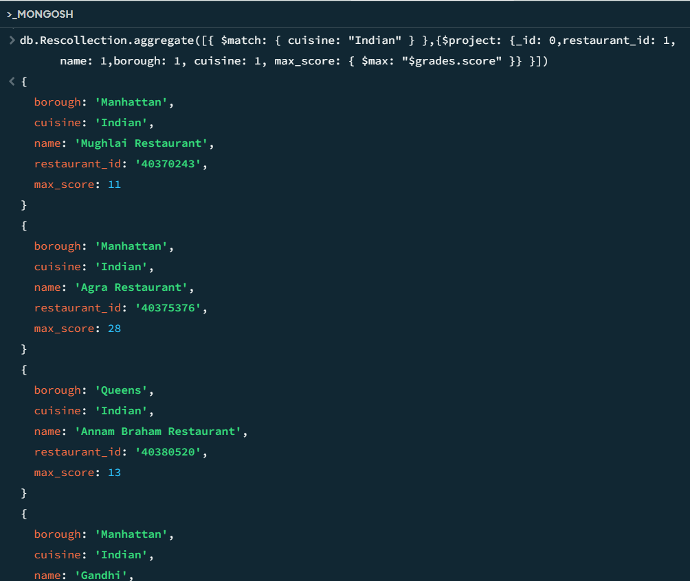

- Write a MongoDB query to find the restaurant Id, name, borough, cuisines, and score for those restaurants which contain 'bi' as last three letters for its name.

db.Rescollection.find({ name: { $regex: /bi$/i } },{_id: 0,restaurant_id: 1, name: 1,borough: 1, cuisine: 1, "grades.score": 1})

\

- Write a MongoDB query to find the restaurant Id, name, borough, cuisines, and score for those restaurants which contain 'il' as last three letters for its name.
db.Rescollection.find({ name: { $regex: /il$/i } },{_id: 0,restaurant_id: 1, name: 1,borough: 1, cuisine: 1, "grades.score": 1})

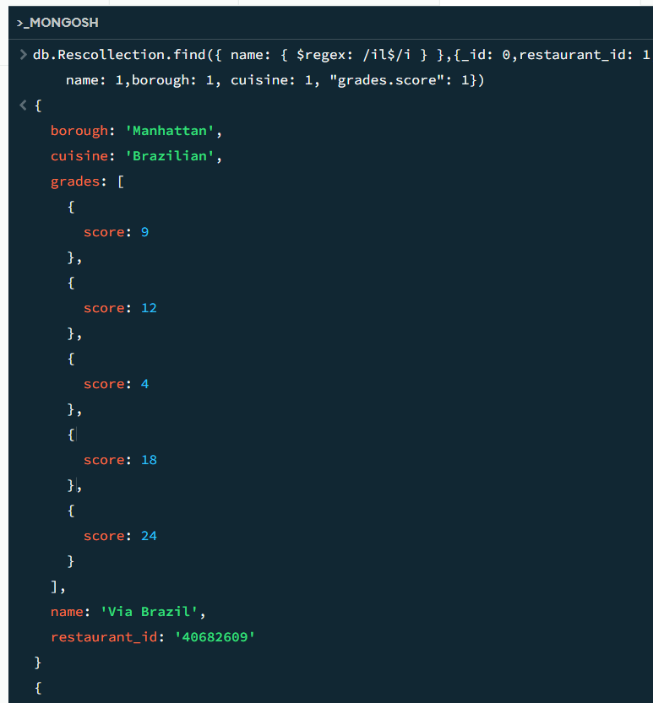

- show frequency count of restaurants by cuisines names.
db.rescollection.aggregate([{$group: {_id:"$cuisine", freqeuncy:{$sum:1}}}, {$sort:{frequency:-1}}])
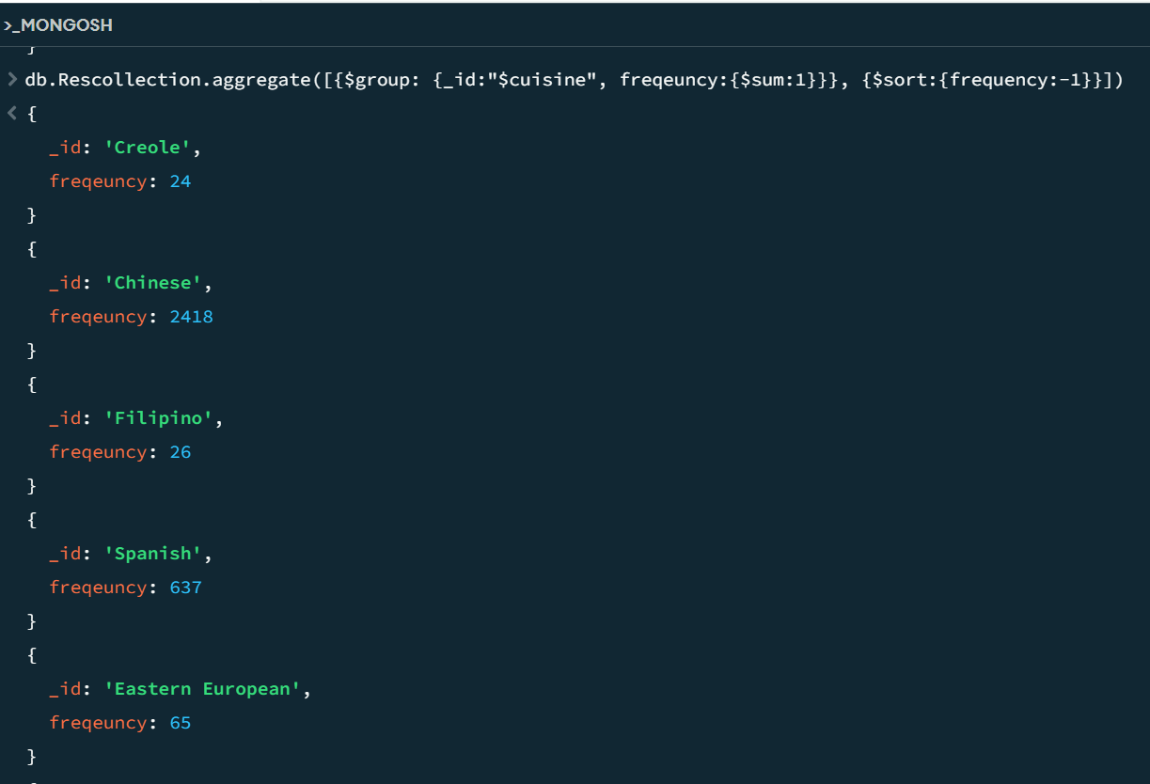

- Write a query to show all the restaurant Id, name, borough, cuisines, and score for those restaurants which contain 'il' anywhere in its name.
db.Rescollection.find({ name: { $regex: /il/i } },{_id: 0,restaurant_id: 1, name: 1,borough: 1, cuisine: 1, "grades.score": 1})
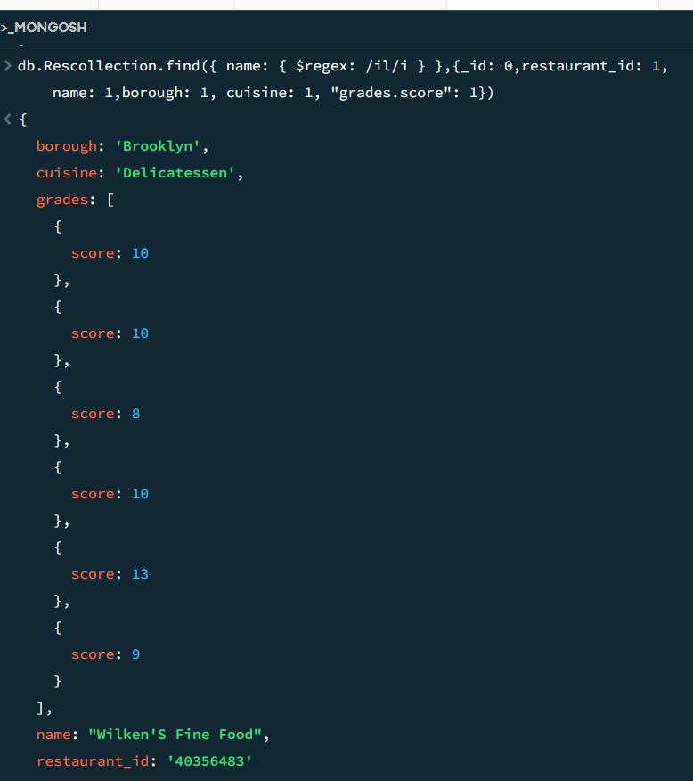

`

- Show document/record counts that has street and not street in addresses.

db.rescollection.countDocuments({"address.street":{$exists:true}})
db.rescollection.countDocuments({"address.street":{$exists:false}})
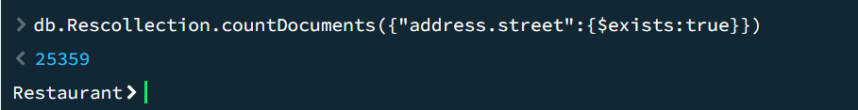

- Write a MongoDB query to find the restaurants which do not prepare any cuisine of 'American' and achieved a score more than 70 and located in the longitude less than -65.754168

db.Rescollection.find({$and : [{cuisine:{$ne:"American "}},{"grades.score":{$gt:70}},{"address.coord.1":{$lt:65.754168}}]})

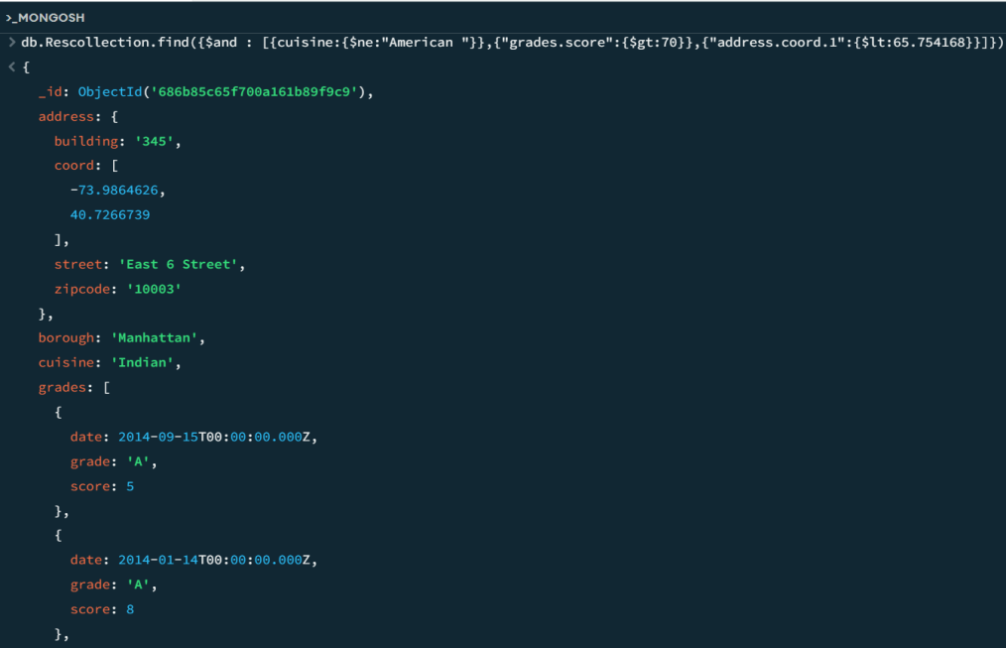

- Write a MongoDB query which will select the restaurant Id, name and grades for those restaurants which returns 0 as a remainder after dividing the score by 7.
db.Rescollection.find( { "grades.score": { "$mod": [7, 0] } }, { "restaurant_id": 1, "name": 1, "grades": 1, "_id": 0 })
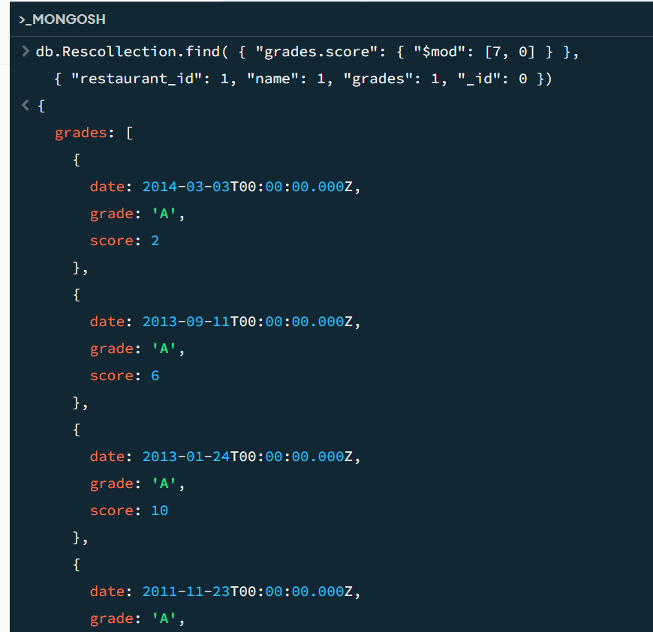

Data analysis using python and mongodb

- Create database – restaurant, create collection – rescollection. Insert the documents into collections.
- Display all the documents in the collection restaurants.
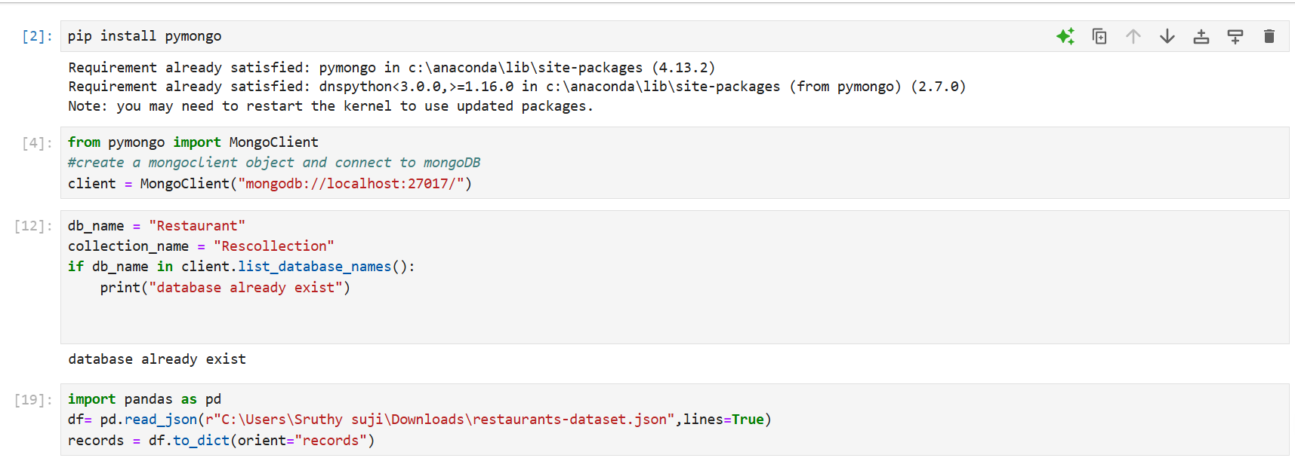

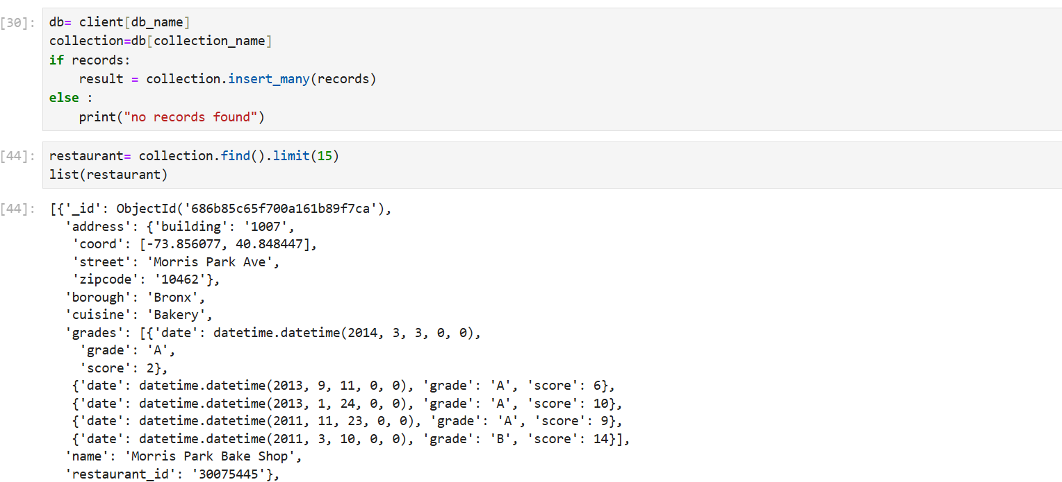

`
- Display the fields restaurant_id, name, borough, and zip code, but exclude the field _id for all the documents in the collection restaurant.

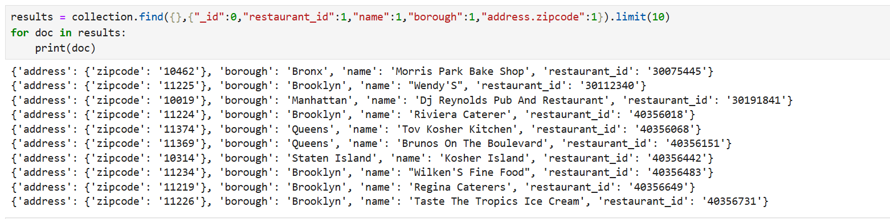

- Find the restaurants who achieved a score more than 90.
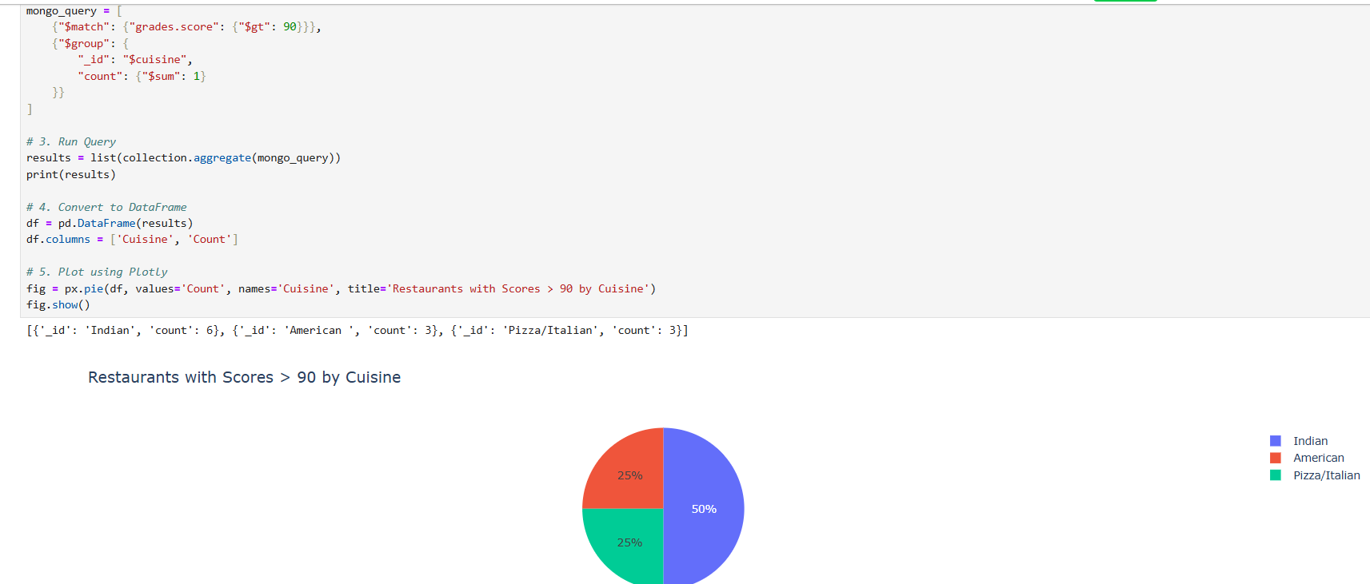

- Show the restaurants that achieved a score, more than 80 but less than 100.
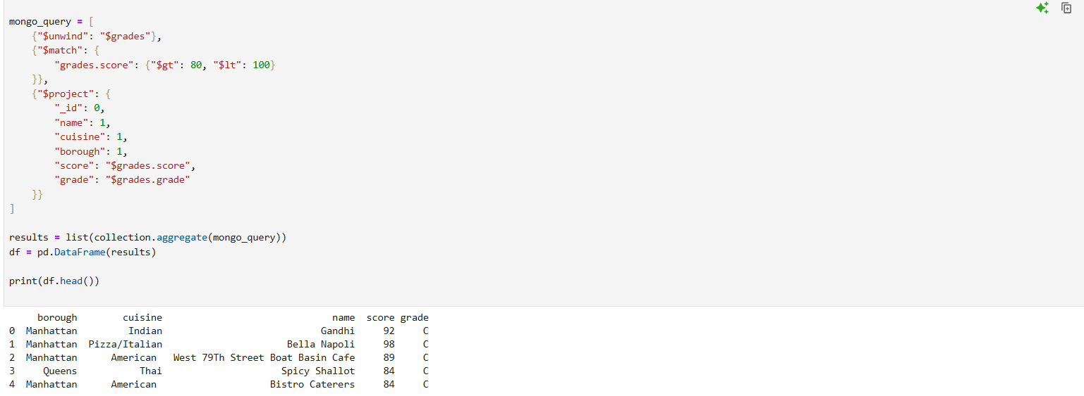

- Write Query to show the restaurants that do not prepare any cuisine of american & their grade score > 70.
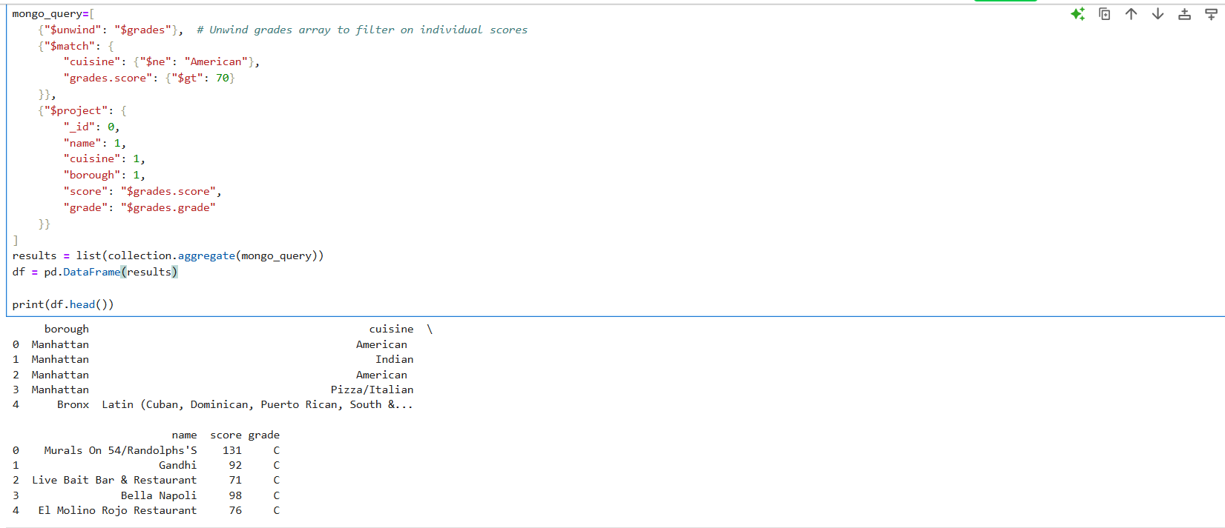

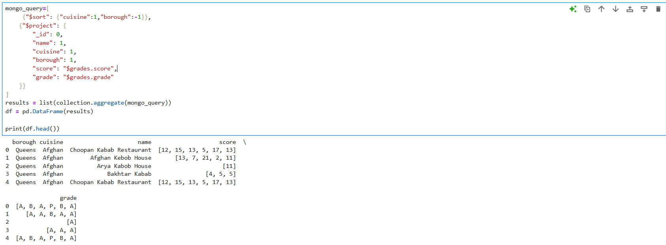
- Write a MongoDB query to arrange the name of the cuisine in an ascending order and for that same borough arranged in descending order.

- Write a MongoDB query to arrange the name of the cuisine in descending order and cuisines not equal to "Italian"
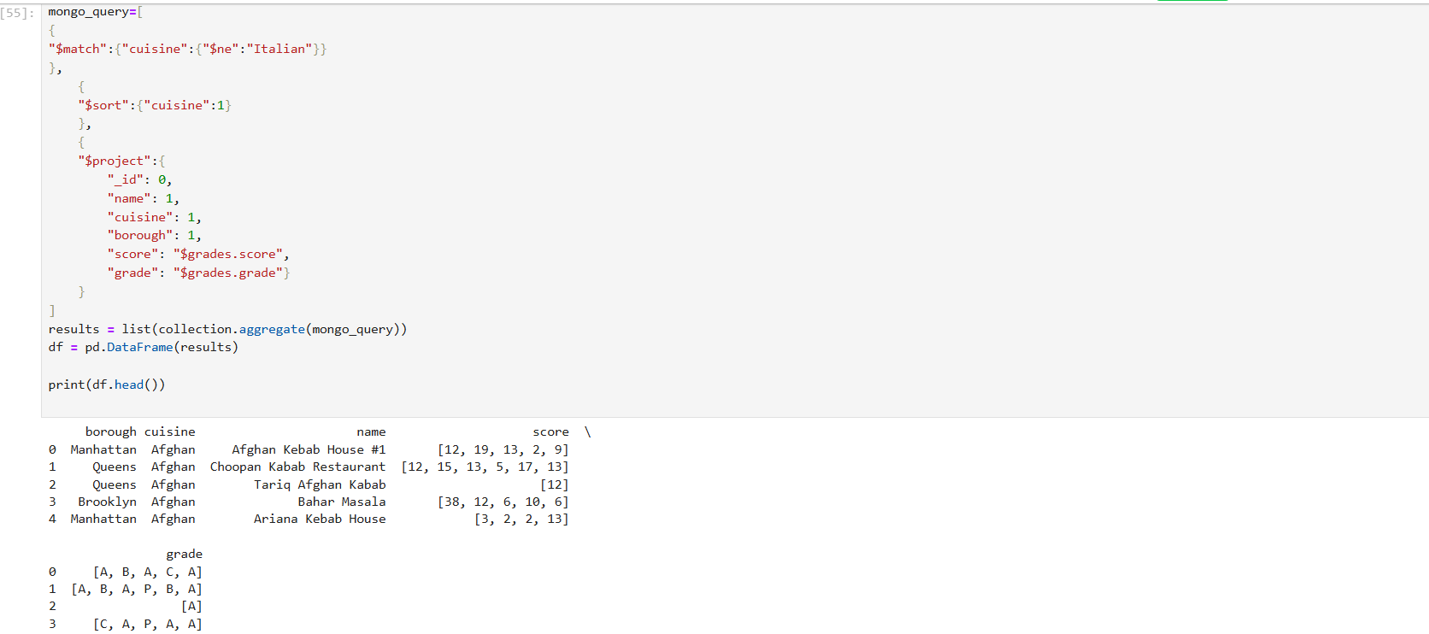

- Show the restaurant Id, name, borough and cuisines for those restaurants which prepared dish except 'American ' and 'Chinese' or restaurant's name begins with letter 'Bil'.

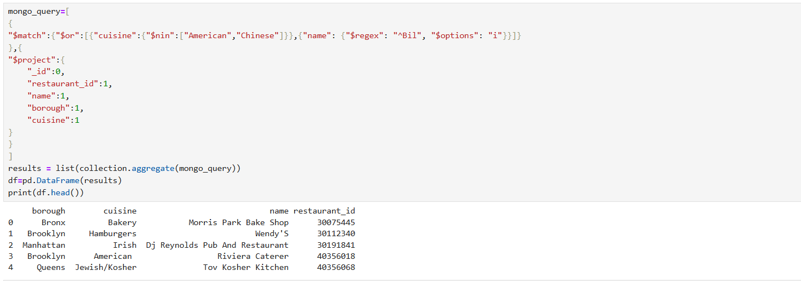

- Show the restaurant Id, name, borough and cuisines and max score for restaurant serving “Indian” as cuisines.
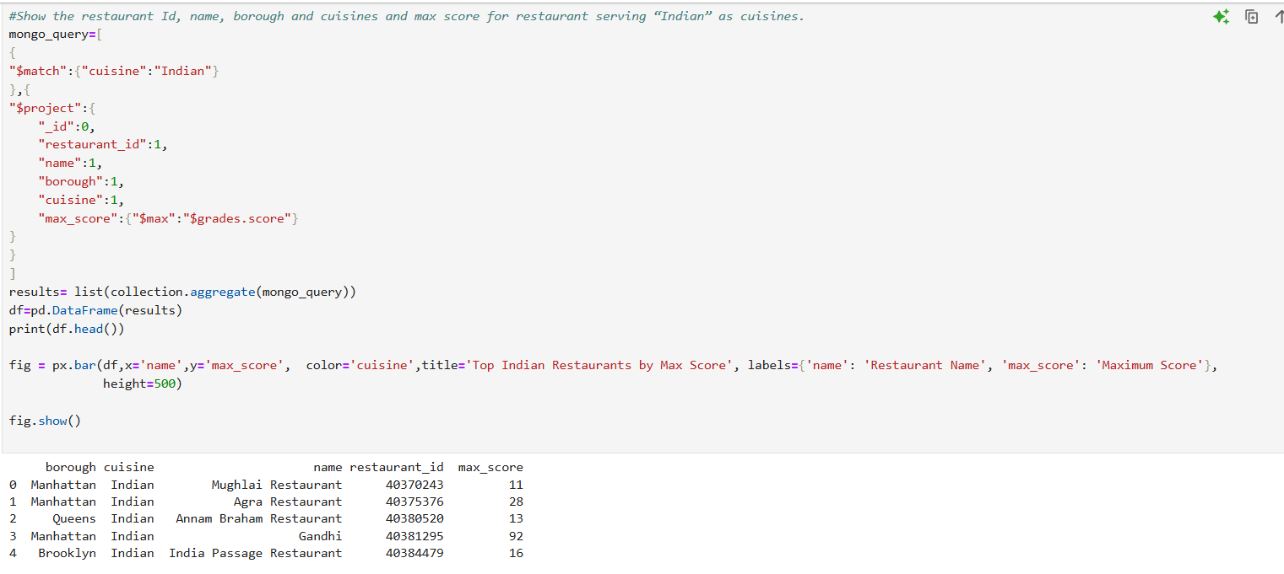

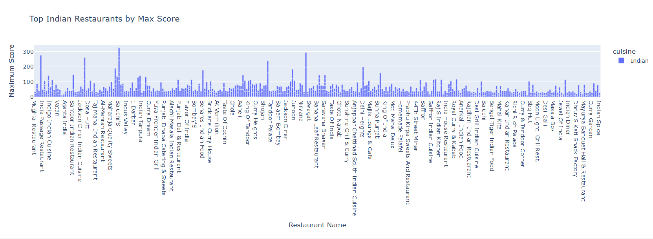

- Show frequency count of restaurants by cuisines names.
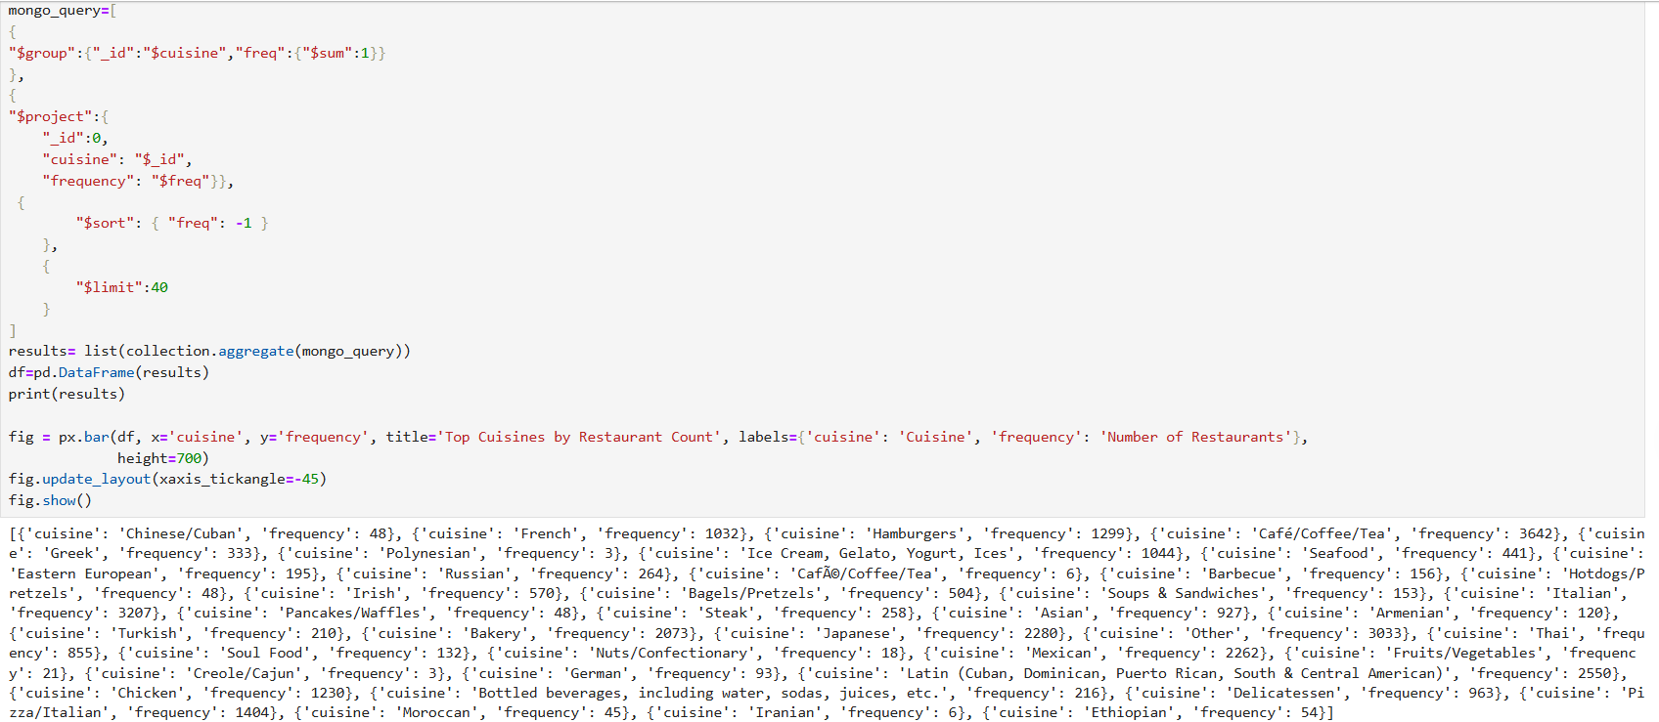

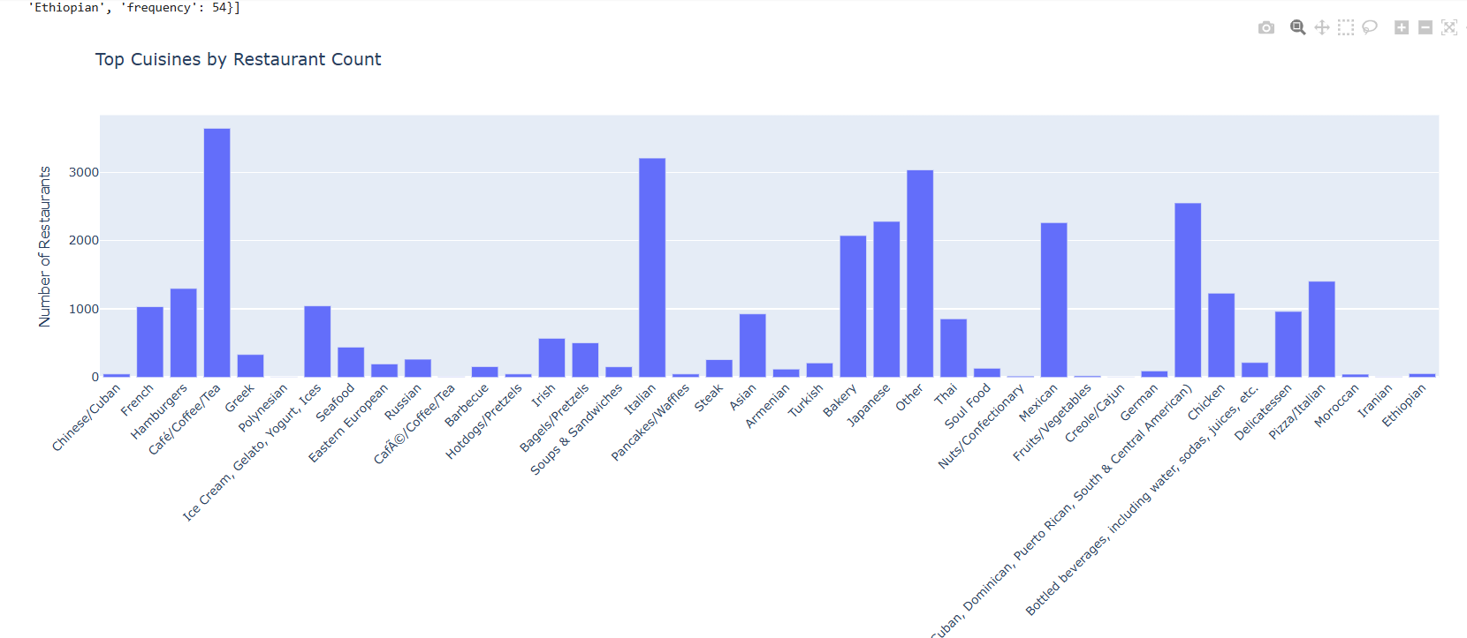

- Write a MongoDB query to find the restaurant Id, name, borough, cuisines, and score for those restaurants which contain 'bi' as last three letters for its name.
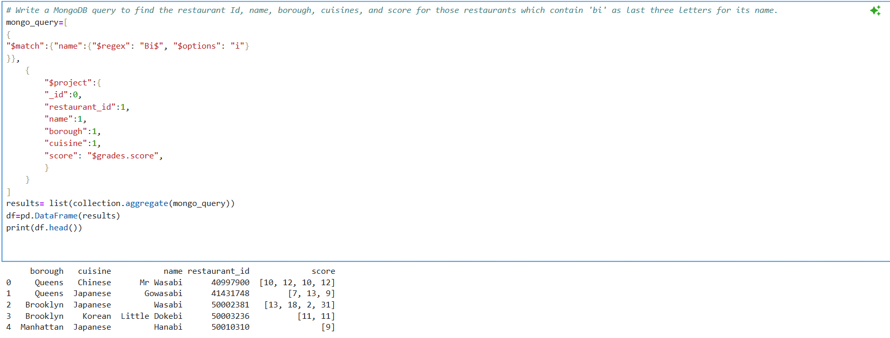

- Write a MongoDB query to find the restaurant Id, name, borough, cuisines, and score for those restaurants which contain 'il' as last three letters for its name.
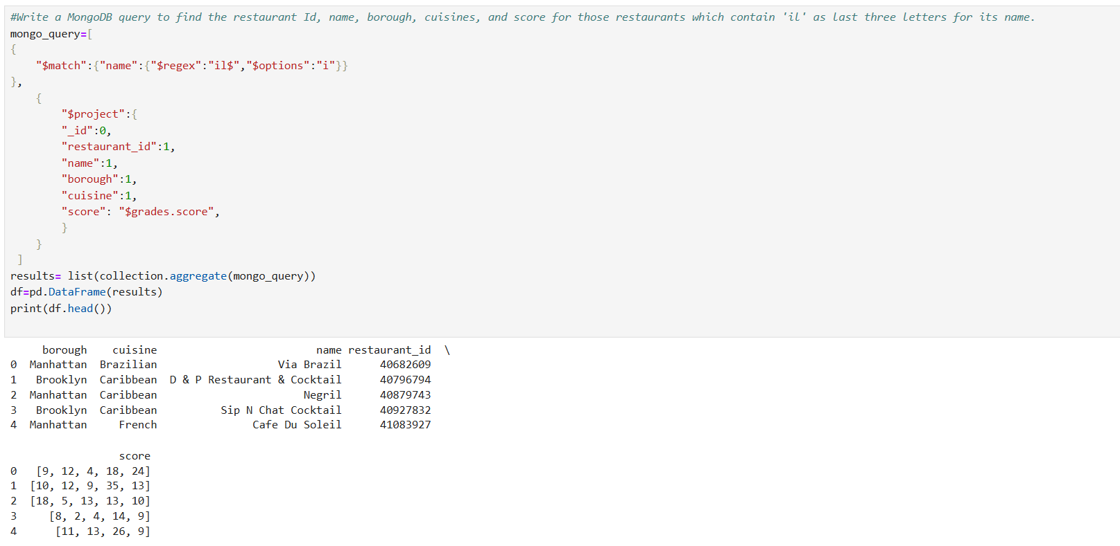

- Write a query to show all the restaurant Id, name, borough, cuisines, and score for those restaurants which contain 'il' anywhere in its name.
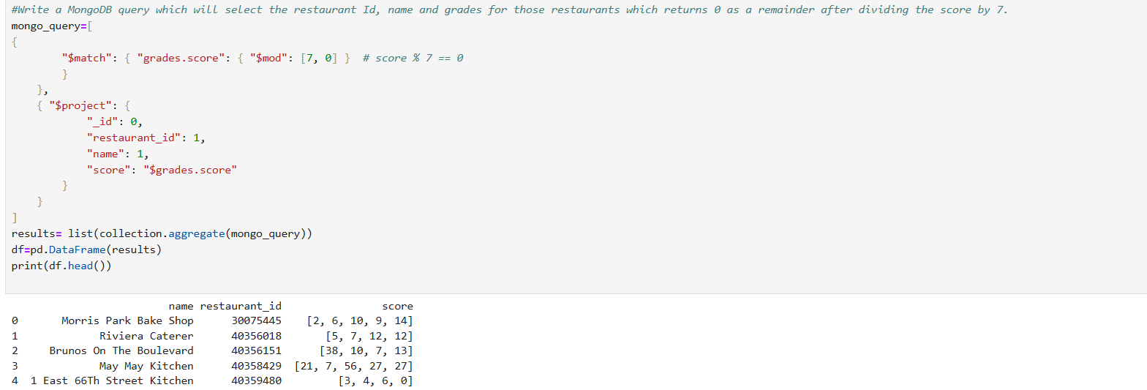

- Write a MongoDB query which will select the restaurant Id, name and grades for those restaurants which returns 0 as a remainder after dividing the score by 7.
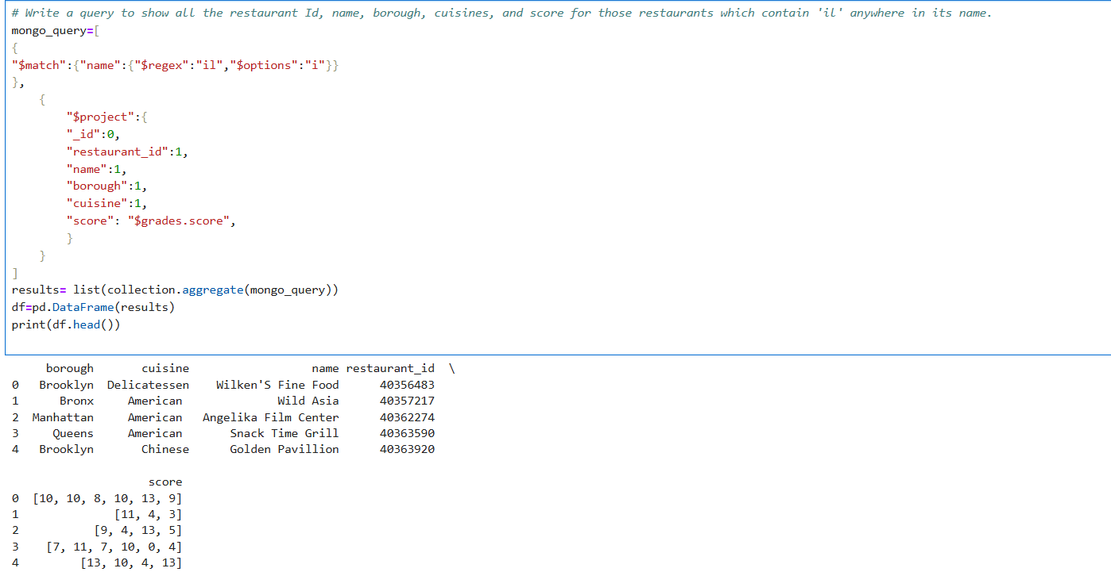

- Show document/record counts that has street and not street in addresses.
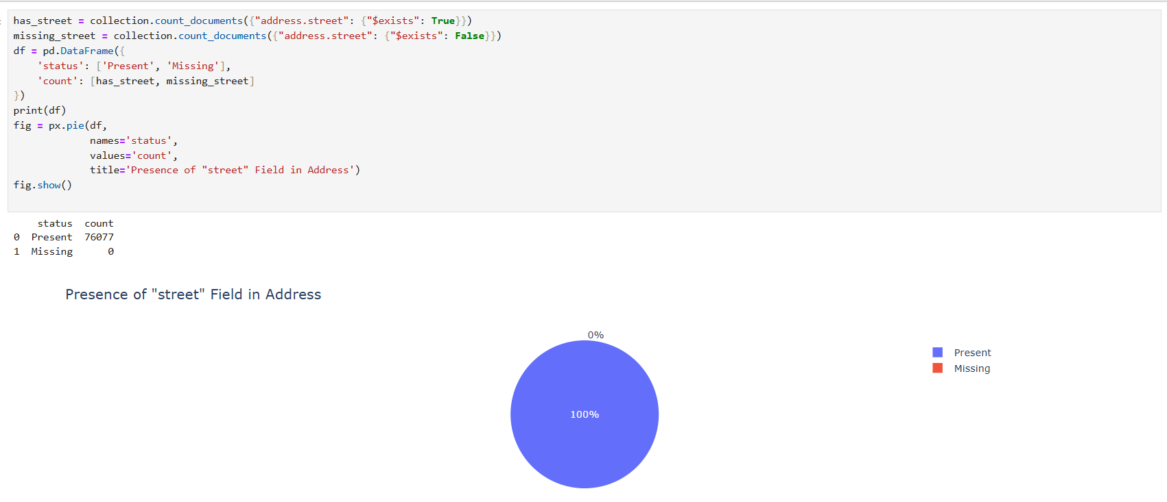

- Write a MongoDB query to find the restaurants which do not prepare any cuisine of 'American' and achieved a score more than 70 and located in the longitude less than 65.754168
